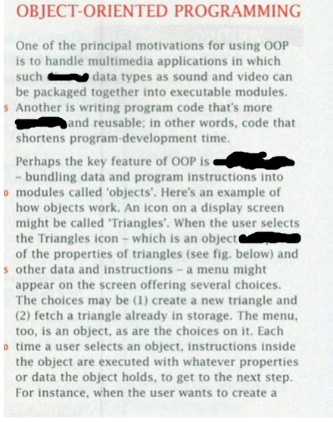

**composed, diverse , encapsulation , intuitive**

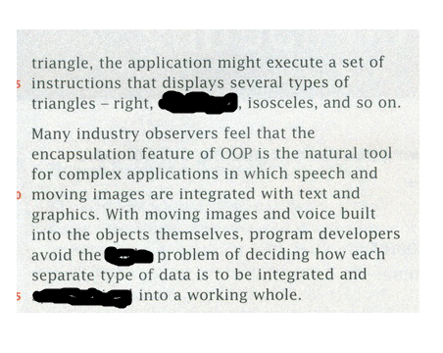

**Equilateral , sticky , synchronized**

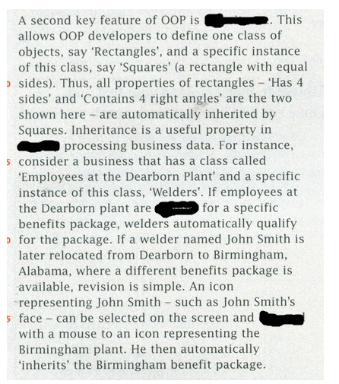

**Inheritance , rapidly , eligible , dragged**

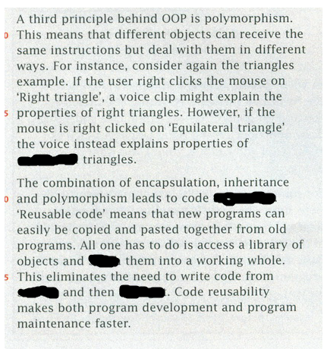

**Equilateral , reusability , stitch , scratch , debug**

